UNITED STATES
SECURITIES AND EXCHANGE COMMISSION
Washington, D.C. 20549

SCHEDULE 14A

Proxy Statement Pursuant to Section 14(a) of the
Securities Exchange Act of 1934
Filed by the Registrant ☒
Filed by a Party other than the Registrant ☐
Check the appropriate box:
☐ |  |  | Preliminary Proxy Statement
☐ |  |  | Confidential, for Use of the Commission Only (as permitted by Rule 14a-6(e)(2))
☐ |  |  | Definitive Proxy Statement
☒ |  |  | Definitive Additional Materials
☐ |  |  | Soliciting Material Pursuant to §240.14a-12

Decoy Therapeutics Inc.

(Name of Registrant as Specified in its Charter)
(Name of Person(s) Filing Proxy Statement, if other than the Registrant)
Payment of Filing Fee (Check the appropriate box):
☒ |  |  | No fee required.
☐ |  |  | Fee paid previously with preliminary materials.
☐ |  |  | Fee computed on table in exhibit required by Item 25(b) per Exchange Act Rules 14a-6(i)(1) and 0-11.
 |  |  | (1) |  |  | Amount Previously Paid:
 |  |  | (2) |  |  | Form, Schedule or Registration Statement No.:
 |  |  | (3) |  |  | Filing Party:
 |  |  | (4) |  |  | Date Filed:

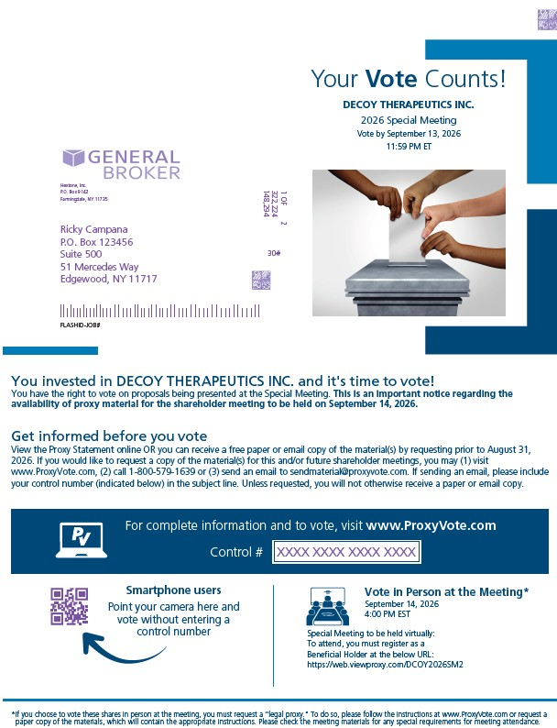
Your Vote Counts! DECOY THERAPEUTICS INC. 2026 Annual Meeting Vote by July 13, 2026 11:59 PM ET Hextone, Inc. P.O. Box 9142 Farmingdale, NY 11735 1 OF 2 322,224 148,294 30# Ricky Campana P.O. Box 123456 Suite 500 51 Mercedes Way Edgewood, NY 11717 FLASHID-JOB# You invested in DECOY THERAPEUTICS INC. and it's time to vote! You have the right to vote on proposals being presented at the Annual Meeting. This is an important notice regarding the availability of proxy material for the shareholder meeting to be held on July 14, 2026. Get informed before you vote View the Form 10-K, Proxy Statement online OR you can receive a free paper or email copy of the material(s) by requesting prior to June 30, 2026. If you would like to request a copy of the material(s) for this and/or future shareholder meetings, you may (1) visit www.ProxyVote.com, (2) call 1-800-579-1639 or (3) send an email to sendmaterial@proxyvote.com. If sending an email, please include your control number (indicated below) in the subject line. Unless requested, you will not otherwise receive a paper or email copy. For complete information and to vote, visit www.ProxyVote.comControl # Smartphone users Point your camera here and vote without entering a control number Vote in Person at the Meeting* July 14, 2026 10:00 AM CDT Annual Meeting to be held virtually: To attend, you must register as a Beneficial Holder at the below URL: https://web.viewproxy.com/dcoy/2026*If you choose to vote these shares in person at the meeting, you must request a “legal proxy.” To do so, please follow the instructions at www.ProxyVote.com or request a paper copy of the materials, which will contain the appropriate instructions. Please check the meeting materials for any special requirements for meeting attendance

Vote at www.ProxyVote.com FLASHID-JOB# Control # XXXX XXXX XXXX XXXX THIS IS NOT A VOTABLE BALLOT This is an overview of the proposals being presented at the upcoming shareholder meeting. Please follow the instructions on the reverse side to vote these important matters. DECOY THERAPEUTICS INC. 2026 Annual Meeting Vote by July 13, 2026 11:59 PM ET Voting Items 1. Election of Directors Nominees: 1 Patricia Gauthier 2 Jonathan Lieber 3 Frederick E. Pierce 2. A proposal to approve, on a non-binding basis, the compensation paid by the Company to its named executive officers as disclosed in the proxy statement. 3. A proposal to ratify the appointment of Ernst & Young LLP as the Company's independent registered public accounting firm for the fiscal year ending December 31, 2026. NOTE: Such other business as may properly come before the meeting, and any adjournment or postponement thereof. Board Recommends For For For For For Under New York Stock Exchange rules, brokers may vote “routine” matters at their discretion if your voting instructions are not communicated to us at least 10 days before the meeting. We will nevertheless follow your instructions, even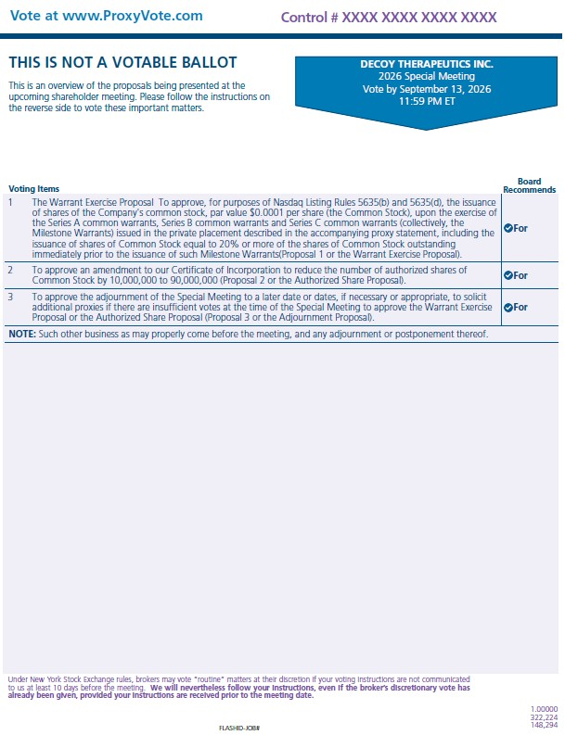 if the broker’s discretionary vote has already been given, provided your instructions are received prior to the meeting date. FLASHID-JOB# 1.00000 322,224 148,294

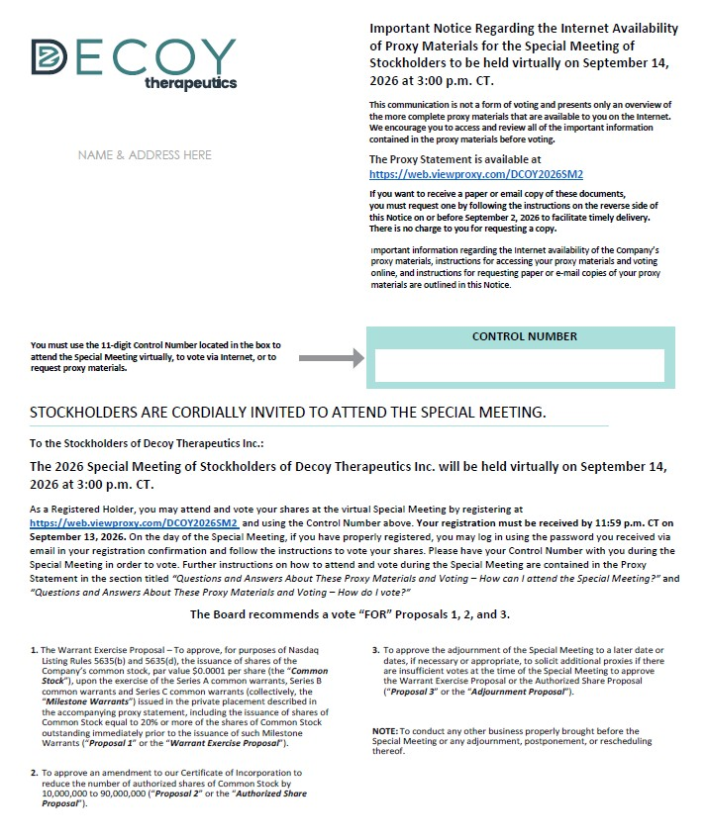

Important Notice Regarding the Internet Availability of Proxy Materials for the Annual Meeting of Stockholders to be held virtually on July 14, 2026 at 10:00 a.m. CT. This communication is not a form of voting and presents only an overview of the more complete proxy materials that are available to you on the Internet. We encourage you to access and review all of the important information contained in the proxy materials before voting. The Proxy Statement and Annual Report are available at https://web.viewproxy.com/DCOY/2026If you want to receive a paper or email copy of these documents, you must request one by following the instructions below on or before July 2, 2026 to facilitate timely delivery. There is no charge to you for requesting a copy. Important information regarding the Internet availability of the Company’s proxy materials, instructions for accessing your proxy materials and voting online, and instructions for requesting paper or e-mail copies of your proxy materials are outlined in this Notice. NAME & ADDRESS HERE You must use the 11-digit Control Number located in the box to attend the Annual Meeting virtually, to vote via Internet, or to request proxy materials. CONTROL NUMBER STOCKHOLDERS ARE CORDIALLY INVITED TO ATTEND THE ANNUAL MEETING. To the Stockholders of Decoy Therapeutics Inc.: The 2026 Annual Meeting of Stockholders of Decoy Therapeutics Inc. will be held virtually on July 14, 2026 at 10:00 a.m. CT. As a Registered Holder, you may attend and vote your shares at the virtual Annual Meeting by registering at https://web.viewproxy.com/DCOY/2026 and using the Control Number above. Your registration must be received by 11:59 p.m. on July 12, 2026. On the day of the Annual Meeting, if you have properly registered, you may log in using the link you received via email in your registration confirmation and follow the instructions to vote your shares. Please have your Control Number with you during the Annual Meeting in order to vote. Further instructions on how to attend and vote during the Annual Meeting are contained in the Proxy Statement in the section titled “Questions and Answers About These Proxy Materials and Voting – How can I attend the Annual Meeting?” and “Questions and Answers About These Proxy Materials and Voting – How do I vote?” The Board recommends a vote “FOR” Proposals 1, 2, and 3. 1. Election of Directors: 01. Patricia Gauthier 02. Jonathan Lieber 03. Frederick E. Pierce 3. A proposal to ratify the appointment of Ernst & Young LLP as the Company’s independent registered public accounting firm for the fiscal year ending December 31, 2026. 2. A proposal to approve, on a non-binding basis, the compensation paid by the Company to its named executive officers as disclosed in the proxy statement. NOTE: To conduct any other business properly brought before the Annual Meeting or any adjournment, postponement, or rescheduling thereof.

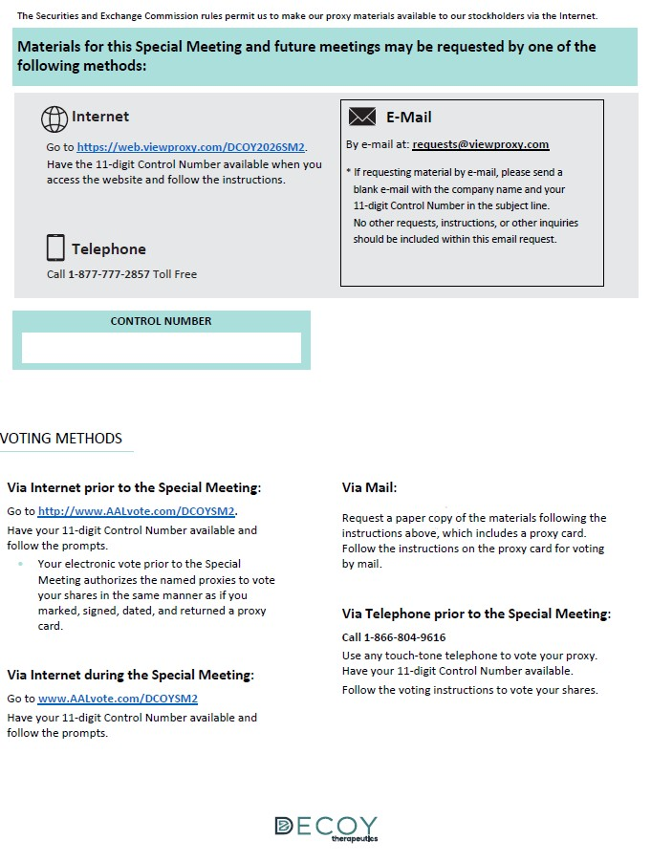

The Securities and Exchange Commission rules permit us to make our proxy materials available to our stockholders via the Internet. Materials for this Annual Meeting and future meetings may be requested by one of the following methods: Internet Go to https://web.viewproxy.com/DCOY/2026. Have the 11-digit Control Number available when you access the website and follow the instructions. Telephone Call 1-877-777-2857 Toll Free E-Mail By e-mail at: requests@viewproxy.com * If requesting material by e-mail, please send a blank e-mail with the company name and your 11-digit Control Number in the subject line. No other requests, instructions, or other inquiries should be included within this email request. CONTROL NUMBER VOTING METHODS Via Internet prior to the Annual Meeting: Go to http://www.AALvote.com/DCOY. Have your 11-digit Control Number available and follow the prompts. Your electronic vote prior to the Annual Meeting authorizes the named proxies to vote your shares in the same manner as if you marked, signed, dated, and returned a proxy card. Via Internet during the Annual Meeting: Go to http://www.AALvote.com/DCOY Have your 11-digit Control Number available and follow the prompts.

